**Peshawar:**

Bala Hissar Fort

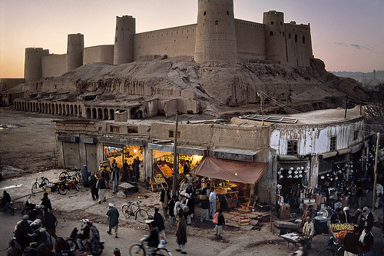

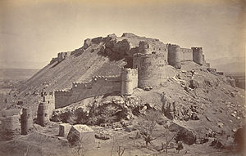

**Bala Hissar** also spelt **Bala Hisar**, is a historic fortress located in Peshawar, Khyber Pakhtunkhwa, Pakistan. The fort was used as a royal residence for the Durrani Empire, and was renovated during Sikh rule. The fort now serves as headquarters for Pakistan's Frontier Corps. The fort stands on a high mound in the northwestern corner of Peshawar City. Not long ago, the fort used to be conspicuously away from the old city of Peshawar, but now the construction of new buildings has covered space between the old city and the fort. However, the fort's position on a high mound gives a commanding and panoramic view of Peshawar and the entire Peshawar valley.

Mahabat Khan Mosque

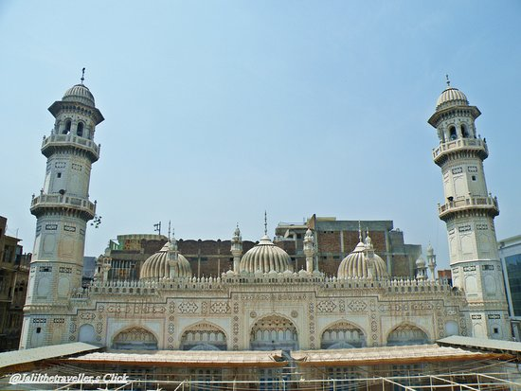

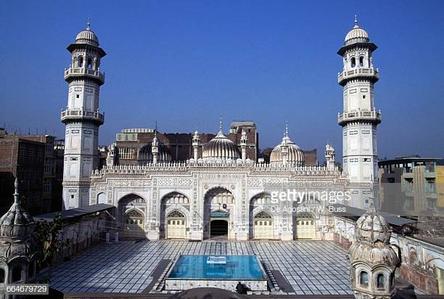

The **Mahabat Khan Mosque** sometimes spelt **Mohabbat Khan Mosque**, is a 17th-century Mughal-era mosque in Peshawar, Pakistan. The mosque was built in 1630, and named after the Mughal governor of Peshawar, Nawab Mahabat Khan bin Ali Mardan Khan, known alternatively as **Mahabat Khan** and **Ali Mardan Khan**. The mosque's white marble façade is considered to be one of Peshawar's most iconic sights. The mosque was built between 1660 and 1670, on what was the highest point in the old city. The minarets of the Mohabbat Khan Mosque were frequently used in Sikh times for hanging prisoners. Five people per day were hanged from the minarets to correspond to the Sunni Islamic practice of praying five times per day, as a substitute for the gallows’.

Cuningham Clock Tower

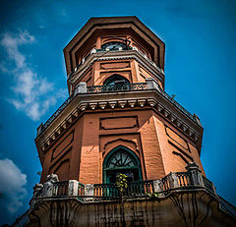

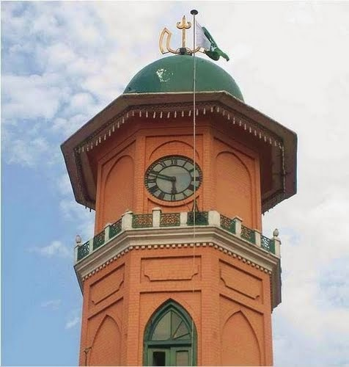

The **Cunningham Clock Tower** in Peshawar, Khyber-Pakhtunkhwa, Pakistan, was built in 1900, "in commemoration of the Diamond Jubilee of Her Majesty the Queen Empress". The tower was named after Sir George Cunningham, former British governor and political agent in the province. Designed by James Strachan, the Municipal Engineer of Peshawar, the foundation stone was laid by the George Cunningham, Governor of the North West Frontier Province (now Khyber Pakhtunkhwa) in 1898. It was opened to the public in 1900 to commemorate the Diamond Jubilee of Queen Victoria. The tower is 31 feet in diameter. Its base is 13 by 4 metres (43 ft × 13 ft) and stands 26 metres (85 ft) tall at the Ghanta Ghar Chowk (“Clock Tower Square”).

Bab-e-Khyber

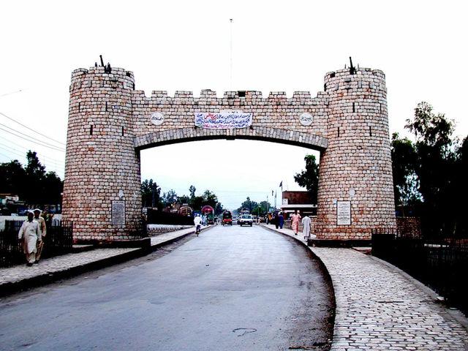

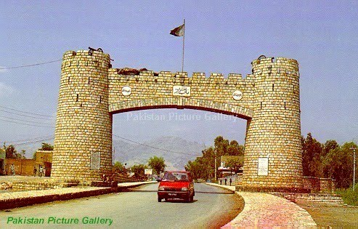

**Bab-e-Khyber** **"Khyber Gate"**) is a monument which stands at the entrance of the Khyber Pass in the Federally Administered Tribal Areas of Pakistan. The gate is immediately west of Peshawar, while the historic Jamrud Fort is adjacent to the gate. The gate was built in 1964 by the military government of Ayub Khan. Khyber Gate is considered to be the most famous post-independence structure in Khyber Agency.

Peshawar Museum

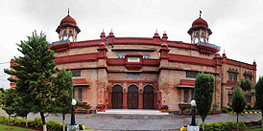

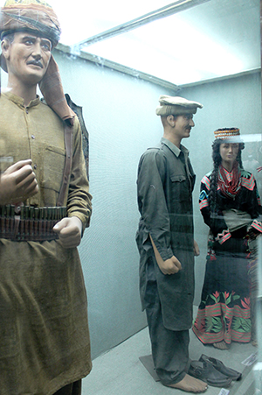

The **Peshawar Museum** is a museum located in Peshawar, capital of Pakistan’s Khyber Pakhtunkhwa province. The Peshawar Museum is notable for its collection of Buddhist artwork dating from the ancient Gandhara Empire. The Peshawar Museum was founded in 1907 as "Victoria Hall," in memory of Queen Victoria. The two-story building was built in a syncretic architectural style consisting of British, Hindu, Buddhist and Mughal Islamic styles. The museum initially had only one exhibition hall, but two more were added in 1969–70. In 2004–05, the museum was further expanded with the construction of a new block with two galleries, two halls for the museum's collection in storage, offices for the provincial directorate of archaeology, a conservation laboratory and a cafeteria. The historic exhibition hall was also renovated at that time.

Kanishka Stupa

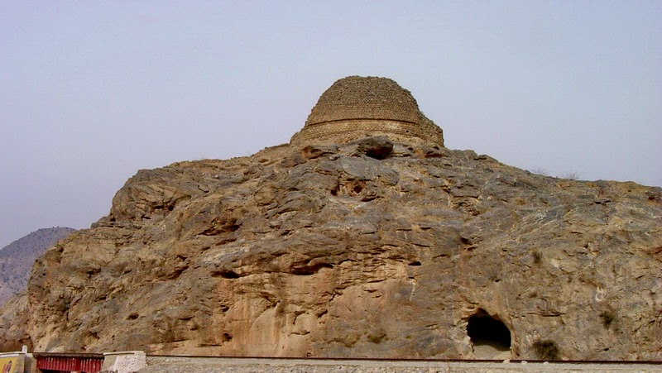

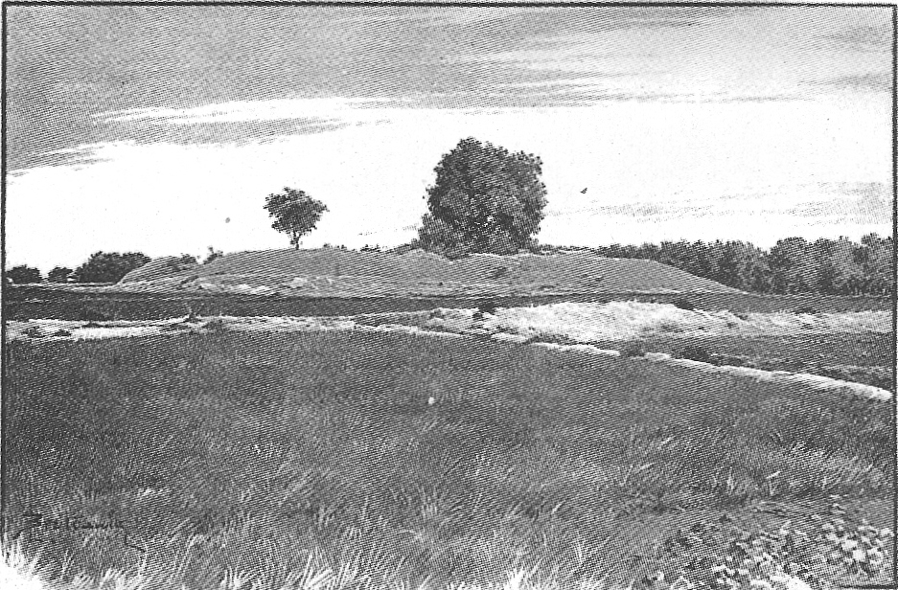

The **Kanishka stupa** was a monumental stupa established by the Kushan king Kanishka during the 2nd century CE in today's Shaji-ki-Dheri on the outskirts of Peshawar, Pakistan.The stupa was built during the Kushan era to house Buddhist relics, and would become perhaps the tallest buildings in the ancient world. The stupa is also famous for its Buddhist relics, which were transferred to the U Khanti Hall at Mandalay Hill, in Mandalay, Burma after their discovery.